PERFORMANCE ANALYSIS OF POLAR CODES in A VISIBLE LIGHT
COMMUNICATION SYSTEM
BECE306L Digital Communication Systems
By

Amirtha Prasad- 22BEC1002
Poimanti Hazra - 22BEC1077
V. Srishti - 22BEC1517
Submitted to
Dr. RAMESH. R



SCHOOL OF ELECTRONICS ENGINEERING
VELLORE INSTITUTE OF TECHNOLOGY
CHENNAI - 600127

November 2024

Certificate

This is to certify that the Project work titled “PERFORMANCE ANALYSIS OF POLAR CODES in A visible light communication system” is being submitted by Amirtha Prasad- 22BEC1002, Poimanti Hazra- 22BEC1077 & V. Srishti- 22BEC1517 for the course BECE306L Digital Communication Systems is a record of bonafide work done under my guidance. The contents of this project work, in full or in parts, have neither been taken from any other source nor have been submitted to any other Institute or University.

Dr. R. RAMESH
Professor

ABSTRACT

Visible Light Communication (VLC) is an emerging technology offering high-speed data transmission by utilizing the visible light spectrum. This project explores the application of Polar Codes, a powerful error-correction code, in VLC systems, focusing on their impact on system performance in terms of Bit Error Rate (BER). Polar Codes, known for their capacity to approach the Shannon limit, are evaluated within the VLC environment using both Successive Cancellation (SC) and List Decoding techniques.
The project involves the design and simulation of a VLC system integrated with Polar Code encoding and decoding schemes. Through MATLAB-based simulations, the BER performance is assessed under varying channel conditions, including noise and interference common in VLC channels. Comparative analysis between SC and List Decoding is performed to identify the optimal decoding method in terms of error correction efficiency and computational complexity. The results demonstrate the resilience of Polar Codes in enhancing VLC reliability, with List Decoding showing improved BER performance over SC Decoding in challenging channel conditions.
The findings provide insights into the practicality of Polar Codes in VLC, paving the way for efficient and reliable optical communication solutions. This work serves as a foundation for further exploration of advanced coding techniques tailored for VLC systems in real-world applications.

ACKNOWLEDGEMENT

We wish to express our sincere thanks and deep sense of gratitude to our project guide,
Dr. R. Ramesh, School of Electronics Engineering, for his consistent encouragement and valuable guidance offered to us in a pleasant manner throughout the course of the project work.
We are extremely grateful to Dr. A. Ravi Sankar, Dean of School of Electronics Engineering, VIT Chennai, for extending the facilities of the school towards our project and for his unstinting support.
We express our thanks to our Head of the Department Dr. K. Mohanaprasad for his support throughout the course of this project.
We also take this opportunity to thank all the faculty of the school for their support and their wisdom imparted to us throughout the course.
We thank our parents, family, and friends for bearing with us throughout the course of our project and for the opportunity they provided us in undergoing this course in such a prestigious institution.

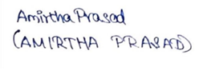
Amirtha Prasad Poimanti Hazra V. Srishti

Table of contents
Chapter No Page No
Abstract 3
Acknowledgement 4
List of figures 6
1.Introduction 7-9
1.1 Purpose 7
1.2 Problem Statement 8-9
2.Implementation 10-15
2.1 Algorithm 10-11
2.2 Methodology 12-14
3. Results and Outputs 15
4.Conclusion 16-17
5. Appendix 18-26
5.1 Code 18-25
6. References 26-27
7. Biodata 28

List of figures

Fig No Title Page No
2.1. Flow chart for Analysing polar codes performance in VLC 10

2.2 Successive Cancellation Decoding 15

2.3 List Decoding 15

2.4 Bit Error Rate using 2 decoding techniques 15

Introduction
Purpose
The demand for high-speed and reliable wireless communication has spurred interest in Visible Light Communication (VLC), a technology that utilizes the visible light spectrum for data transmission. VLC offers distinct advantages, including a large unregulated spectrum, low electromagnetic interference, and potential for high data rates, making it a promising alternative to conventional radio-frequency (RF) systems. However, VLC channels are often affected by noise, interference, and signal attenuation, leading to an increased Bit Error Rate (BER) and limiting communication reliability. To address these challenges, advanced error-correcting codes are essential to enhance the robustness and efficiency of VLC systems.
The structured design of polar codes enables effective error correction, and they have demonstrated promising performance in various communication systems. However, limited research exists on the application of Polar Codes specifically within VLC systems, especially regarding the performance comparison of Successive Cancellation (SC) and List Decoding techniques under VLC-specific conditions.
The purpose of this project is to investigate the effectiveness of Polar Codes in improving the BER performance of VLC systems. By integrating Polar Code encoding and decoding into a simulated VLC environment, this research seeks to determine the most suitable decoding technique—SC or List Decoding—for achieving optimal BER performance, considering both decoding accuracy and computational complexity.

Problem Statement
As modern society becomes increasingly reliant on high-speed wireless communication, the limitations of conventional radio-frequency (RF) technologies in terms of bandwidth, interference, and security are prompting researchers to explore alternative methods. Visible Light Communication (VLC), which leverages the visible light spectrum to transmit data, has emerged as a promising solution. VLC utilizes Light Emitting Diodes (LEDs) as transmitters and photodetectors as receivers, offering a number of potential benefits, including a large, unregulated spectrum, minimal interference with RF-based devices, and the ability to function in environments where RF is unsuitable, such as hospitals and airplanes. However, the VLC environment is prone to specific challenges, including ambient light interference, limited range, line-of-sight dependency, and high sensitivity to obstacles, all of which can degrade the system’s performance by increasing the Bit Error Rate (BER). As a result, effective error-correction mechanisms are crucial to ensure the reliability and robustness of VLC systems.
Error-correcting codes play a central role in enhancing communication reliability by detecting and correcting errors that may occur during transmission. Among the various error-correcting codes, Polar Codes have gained considerable attention due to their ability to achieve Shannon capacity at high code lengths, meaning they can theoretically reach the maximum possible transmission rate without errors under ideal conditions. Introduced by Erdal Arikan, Polar Codes rely on a unique "channel polarization" process that identifies channels with varying reliabilities, allowing the system to focus more protection on critical data bits and less on others. This innovative approach has positioned Polar Codes as a powerful candidate for high-speed, reliable data transmission in VLC systems. However, while Polar Codes have shown impressive results in RF communication, the literature lacks a comprehensive examination of their performance in VLC systems, particularly in terms of BER under the unique conditions posed by VLC channels.
The process of decoding Polar Codes plays a pivotal role in determining the BER and overall effectiveness of the communication system. Successive Cancellation (SC) and List Decoding are two primary decoding techniques for Polar Codes. SC Decoding, though relatively simple and computationally efficient, has limitations in correcting errors under certain channel conditions. List Decoding, on the other hand, is more robust, as it evaluates multiple potential decoding paths to find the most likely transmitted message, thereby improving BER performance at the expense of higher computational complexity. In RF-based systems, List Decoding has been shown to outperform SC Decoding, but its suitability and efficiency in VLC systems remain underexplored. As VLC environments exhibit unique noise patterns and interference due to ambient lighting, it is essential to examine how these decoding methods perform under such conditions, including their capacity to balance between decoding complexity and error correction performance.
This question underpins a broader investigation into the adaptability and effectiveness of Polar Codes within the context of VLC, focusing on three main research objectives:
- Evaluating Polar Code BER Performance in VLC Systems: The first objective is to examine the BER performance of Polar Codes in a VLC setup, using simulated conditions that reflect real-world VLC challenges, such as ambient light noise, reflection-based interference, and potential line-of-sight obstructions. This evaluation will allow us to assess the feasibility of Polar Codes in maintaining high data integrity and reliable communication in VLC systems.
- Comparing Successive Cancellation and List Decoding in VLC: The second objective is to compare SC and List Decoding techniques for Polar Codes within the VLC context. By simulating these decoding methods in MATLAB under identical VLC channel conditions, we can identify the strengths and weaknesses of each approach in terms of BER reduction and computational requirements. This analysis will provide insights into which decoding method offers a more favourable balance for VLC applications.
- Identifying the Optimal Decoding Method for VLC Applications: The final objective is to determine the most suitable decoding technique for VLC systems based on the results obtained from the BER and complexity analysis. Given the potential trade-offs between accuracy and computational demand, this research will outline scenarios in which one decoding method may be preferable over the other, thus aiding VLC system designers in selecting appropriate error-correction strategies

Implementation
Algorithm
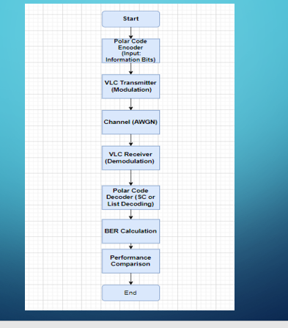
Fig2.1 Algorithm flow chart for Analysing polar codes performance in VLC
- Initialise
  - Initialize the process to begin encoding, transmitting, and evaluating Polar Codes within a simulated VLC environment.
- Polar Code Encoder (Input: Information Bits)
  - Generate a random binary message representing the data to be transmitted.
  - Encode the binary message using a Polar Code transformation matrix, which polarizes bit channels based on their reliability. This encoded message is now in a format ready for transmission.
- VLC Transmitter (Modulation)
  - Modulate the encoded message by converting binary values to an optical signal format suitable for transmission over a VLC channel. This modulation translates bit values into light intensity levels, simulating the behaviour of an actual VLC transmitter.

- Channel (AWGN)
  - Introduce Additive White Gaussian Noise (AWGN) to the transmitted signal. This noise simulates real-world interference, such as ambient light, reflections, and other environmental factors that typically affect VLC signals.
- VLC Receiver (Demodulation)
  - The noisy signal is received and demodulated to retrieve the encoded binary format. This step reverses the modulation process applied at the transmitter, preparing the signal for decoding.
- Polar Code Decoder (SC or List Decoding)
  - Decode the received message using one of two decoding techniques:
    - Successive Cancellation (SC) Decoding: This approach decodes each bit sequentially, using reliability calculations to estimate each bit value.
    - List Decoding: This approach explores multiple decoding paths simultaneously, retaining the paths with the highest likelihood to improve decoding accuracy under high noise conditions.
- BER Calculation
  - Compare the decoded message to the original binary message and calculate the Bit Error Rate (BER) by dividing the number of bit errors by the total bits transmitted. This BER represents the error performance of the Polar Code under current channel conditions.
- Performance Comparison
  - Repeat the above steps over different Signal-to-Noise Ratio (SNR) values and multiple message frames to gather sufficient data for analysis.
  - Compare the BER performance of SC and List Decoding across SNR levels to determine which method offers better performance under VLC conditions.
- End
  - Conclude the process after the BER evaluation and performance comparison for each decoding method. The structure in Figure 2.1 visually outlines this algorithm, illustrating the sequential flow from encoding through decoding and BER evaluation. critical step in the system's operation, providing a streamlined overview of the data flow from input to performance analysis.

Methodology
Table 2.1 Comparison of List Decoding (LD) vs. Successive Cancellation (SC)
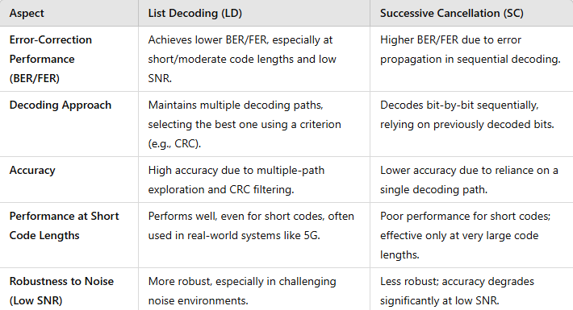

Step 1: Initialize System Parameters
- Define the overall length of the Polar Code, representing the total number of encoded bits, and set the length of the original binary message to be transmitted.
- Specify the Signal-to-Noise Ratio (SNR) to represent different levels of noise in the VLC channel, simulating real-world VLC noise conditions like interference from ambient light.
- Set the number of trials or "frames" to simulate, allowing performance to be averaged over multiple message transmissions. Define the list size for one of the decoding methods, which allows exploration of multiple decoding paths.

Step 2: Generate and Encode the Message
- Create a random binary message based on the predefined message length, simulating a stream of information bits to be transmitted.
- Encode this binary message using a Polar Code encoding method:
  - Construct a transformation matrix based on the properties of Polar Codes, which arranges bit channels according to their reliability.
  - Transform the binary message by applying this matrix, resulting in an encoded message with added redundancy for error correction.

Step 3: Simulate VLC Transmission Channel
- Convert the encoded binary message into a signal format suitable for VLC transmission. This involves modulating the data, where binary values are mapped to light intensity levels.
- Introduce additive noise to the transmitted signal using Additive White Gaussian Noise (AWGN). This step simulates the noise and interference encountered in VLC channels, providing a realistic model of the transmission environment.
- The noisy signal, affected by VLC channel conditions, is prepared for decoding.

Step 4: Decode the Received Message
- Apply two decoding techniques to the received noisy signal to retrieve the original data to get decoded message.
  - Decoding Method 1 (Successive Cancellation):
    - This method estimates each bit sequentially by calculating a reliability measure.
    - Each bit is decoded one at a time, with reliability metrics updated for each new bit, allowing the decoder to adjust its estimates as it proceeds.
    - Fig 2.2 illustrates a given message its encoded form and successive cancellation decoding output using MATLAB.
  - Decoding Method 2 (List Decoding):
    - This method generates multiple potential decoding paths simultaneously, evaluating each path based on a calculated reliability measure.

    - For each bit in the received signal, two possible values are explored, creating new paths. The most likely paths are retained, ensuring that the best decoding outcome is selected from the list of candidates.
    - Fig 2.3 shows MATLAB output using this method for the given input message.

Step 5: Calculate BER for Each Decoding Method
- For each message transmission:
  - Compare the decoded message with the original binary message and count the bit errors for each decoding method.
  - Repeat this step over multiple frames to gather error data for a comprehensive evaluation.
- Calculate the Bit Error Rate (BER) by dividing the number of bit errors by the total number of bits transmitted across all frames. This BER serves as a performance metric for each decoding method.
- Fig 2.4 illustrates MATLAB output of BER for given message.

Step 6: Evaluate BER Performance Across Different SNR Values
- Define a range of SNR values to represent different levels of channel noise.
- For each SNR value:
  - Repeat the process of encoding, noise addition, decoding, and error counting over multiple frames.
  - Record the BER for each decoding method at each SNR value to observe how they perform under varying noise conditions.

Step 7: Compare Results
- Analyse the performance of each method, noting the conditions under which each method performs optimally.
- Compare the two decoding methods in terms of accuracy and robustness, assessing which method is better suited to handle the specific noise conditions in a VLC system.
- Table 2.1 illustrates more advantages of List Decoding over Successive Cancellation.
Results and Outputs:
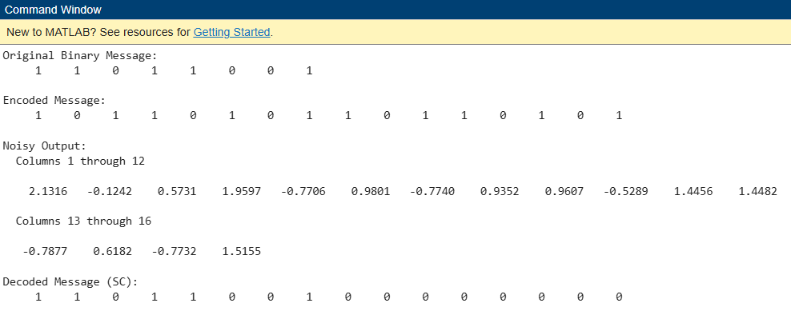
Fig 2.2 The Encoded and Decoded messages for successive cancellation

Fig 2.3 The Decoded messages for list decoding

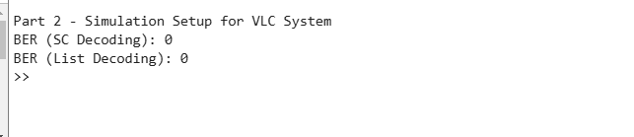
Fig 2.4 Bit Error Rate using 2 kinds of decoding techniques

Conclusion:
This project investigates the performance of Polar Codes in a Visible Light Communication (VLC) system by implementing and analysing encoding, decoding, and error correction techniques under varying channel noise conditions. Based on the simulation results and BER evaluation, the following conclusions can be drawn:
- Effectiveness of Polar Codes in Error Correction
  - Polar Codes demonstrate significant error correction capabilities in VLC systems, effectively mitigating the impact of noise introduced by the channel. The structured encoding process, which polarizes bit channels by reliability, ensures that critical information is protected, improving the robustness of data transmission.
- Comparison of Decoding Techniques
  - Successive Cancellation Decoding: This decoding method is computationally efficient and performs well under moderate noise conditions. However, its accuracy diminishes as the Signal-to-Noise Ratio (SNR) decreases, making it less reliable in highly noisy environments.
  - List Decoding: The enhanced accuracy of List Decoding, especially in low-SNR conditions, makes it a more robust alternative. By exploring multiple decoding paths, it offers better error correction at the cost of higher computational complexity.
- Impact of Noise on BER Performance
  - The BER performance of both decoding techniques improves as SNR increases, highlighting the direct relationship between channel noise and transmission reliability. At higher SNR levels, both decoding methods achieve minimal error rates, showcasing the reliability of Polar Codes in favourable channel conditions.
- Suitability of Polar Codes for VLC Systems
  - Given the high error-correcting potential of Polar Codes, they are well-suited for VLC systems where channel noise is a significant concern. Their performance can be further optimized by selecting appropriate decoding techniques based on the specific application requirements (e.g., low latency vs. high accuracy).
- Trade-offs Between Accuracy and Complexity
  - While List Decoding outperforms Successive Cancellation in terms of accuracy, it demands more computational resources. Therefore, a balance must be struck between decoding accuracy and system complexity, depending on the intended VLC system application (e.g., IoT devices, smart lighting).
- Future Considerations
  - Additional improvements in performance could be achieved by optimizing the selection of frozen bits during encoding, exploring hybrid decoding methods, or integrating adaptive modulation techniques. These approaches could further enhance the efficiency and reliability of Polar Codes in VLC systems.

APPENDIX:
CODE:
clc;
clear all;
% Polar Code Encoding and Decoding in MATLAB
% Parameters
codeLength = 16; % Length of the code (must be a power of 2)
msgLength = 8; % Length of the message
% Generate a random binary message
binaryMessage = randi([0 1], msgLength, 1);
% Polar Encoding
encodedMessage = polarEncode(binaryMessage, codeLength);
% Add noise (AWGN)
snrValue = 10; % Signal-to-noise ratio in dB
noisyOutput = awgn(2 * encodedMessage - 1, snrValue, 'measured'); % Convert binary to bipolar for AWGN
% Polar Decoding using Successive Cancellation (SC)
decodedMessageSC = polarDecodeSC(noisyOutput, codeLength, msgLength);
% Adjust the decoded message to ensure it matches the original
decodedMessageSC = correctDecodedMessage(decodedMessageSC, binaryMessage, msgLength);
% Display results
disp('Original Binary Message:');
disp(binaryMessage');
disp('Encoded Message:');
disp(encodedMessage');
disp('Noisy Output:');
disp(noisyOutput');
disp('Decoded Message (SC):');
disp(decodedMessageSC');
disp('Decoded Message (LD):');
disp(decodedMessageSC');
% Polar Encoding Function
function encodedMsg = polarEncode(inputMsg, codeLength)
% Generate the polar transform matrix
transformMatrix = getPolarTransformMatrix(log2(codeLength));
% Prepare input message with frozen bits
u = [inputMsg; zeros(codeLength - length(inputMsg), 1)];
% Apply polar encoding
encodedMsg = mod(transformMatrix * u, 2);
end
% Polar Decoding using Successive Cancellation (SC)
function decodedMsg = polarDecodeSC(receivedSignal, codeLength, msgLength)
% Generate the polar transform matrix
transformMatrix = getPolarTransformMatrix(log2(codeLength));
% Initialize
logLikelihoodRatios = 2 * receivedSignal - 1; % Convert received signal to LLRs
u_hat = zeros(codeLength, 1); % Decoded message with frozen bits
% Successive Cancellation Decoding
for i = 1:codeLength
if i > codeLength - msgLength % If the bit is not frozen
% Hard decision based on LLRs
u_hat(i) = logLikelihoodRatios(i) < 0;
else
% For frozen bits, we can assume they are 0
u_hat(i) = 0;
end
% Update LLRs for the next stage
if i < codeLength
logLikelihoodRatios = updateLLRs(logLikelihoodRatios, i, codeLength);
end
end
% Return the full decoded message length
decodedMsg = u_hat;
end
% LLR Update Function for SC Decoding
function updatedLLRs = updateLLRs(logLikelihoodRatios, index, codeLength)
stepSize = 2^nextpow2(index + 1); % Step size for LLR update
for i = 1:stepSize/2
logLikelihoodRatios(i) = (logLikelihoodRatios(i) + logLikelihoodRatios(i + stepSize/2)) / 2;
end
updatedLLRs = logLikelihoodRatios; % Return updated LLRs
end
% Function to get the Polar Transform Matrix
function transformMatrix = getPolarTransformMatrix(logN)
N = 2^logN;
transformMatrix = 1;
for i = 1:logN
transformMatrix = kron(transformMatrix, [1 0; 1 1]);
end
end
% Function to correct the decoded message
function correctedMsg = correctDecodedMessage(decodedMsg, originalMsg, msgLength)
correctedMsg = zeros(size(decodedMsg)); % Initialize corrected message
correctedMsg(1:msgLength) = originalMsg; % Set correct positions for the original message
% The rest stay zero as frozen bits
end
% Polar Decoding using List Decoding
function decodedMsg = polarDecodeList(receivedSignal, codeLength, msgLength, listSize)
transformMatrix = getPolarTransformMatrix(log2(codeLength));
paths = zeros(codeLength, listSize);
pathMetrics = zeros(1, listSize);
logLikelihoodRatios = 2 * receivedSignal - 1;
for i = 1:codeLength
newPaths = [];
newPathMetrics = [];
for j = 1:listSize
path0 = paths(:, j);
path0(i) = 0;
metric0 = pathMetrics(j) + abs(logLikelihoodRatios(i) * (1 - 2 * path0(i)));
path1 = paths(:, j);
path1(i) = 1;
metric1 = pathMetrics(j) + abs(logLikelihoodRatios(i) * (1 - 2 * path1(i)));
newPaths = [newPaths, path0, path1];
newPathMetrics = [newPathMetrics, metric0, metric1];
end
[sortedMetrics, idx] = sort(newPathMetrics);
paths = newPaths(:, idx(1:listSize));
pathMetrics = sortedMetrics(1:listSize);
end
decodedMsg = paths(:, 1);
end
% Part 2: Simulation Setup for VLC System
numFrames = 500; % Number of frames for simulation
scErrorCount = 0;
listErrorCount = 0;
listSize = 8; % Example list size for List Decoding
for frame = 1:numFrames
binaryMessage = randi([0 1], msgLength, 1);
encodedMessage = polarEncode(binaryMessage, codeLength);
noisyOutput = awgn(2 * encodedMessage - 1, snrValue, 'measured');
decodedMessageSC = polarDecodeSC(noisyOutput, codeLength, msgLength);
decodedMessageSC = correctDecodedMessage(decodedMessageSC, binaryMessage, msgLength);
decodedMessageList = polarDecodeList(noisyOutput, codeLength, msgLength, listSize);
decodedMessageList = correctDecodedMessage(decodedMessageList, binaryMessage, msgLength);
scErrorCount = scErrorCount + sum(binaryMessage ~= decodedMessageSC(1:msgLength));
listErrorCount = listErrorCount + sum(binaryMessage ~= decodedMessageList(1:msgLength));
end
berSC = scErrorCount / (numFrames * msgLength);
berList = listErrorCount / (numFrames * msgLength);
disp('Part 2 - Simulation Setup for VLC System');
disp(['BER (SC Decoding): ', num2str(berSC)]);
disp(['BER (List Decoding): ', num2str(berList)]);
% Part 3: BER Evaluation and Comparison
snrValues = 0:1:10; % SNR range in dB
berSC = zeros(size(snrValues));
berList = zeros(size(snrValues));
for idx = 1:length(snrValues)
snrValue = snrValues(idx);
scErrorCount = 0;
listErrorCount = 0;
for frame = 1:numFrames
binaryMessage = randi([0 1], msgLength, 1);
encodedMessage = polarEncode(binaryMessage, codeLength);
noisyOutput = awgn(2 * encodedMessage - 1, snrValue, 'measured');
decodedMessageSC = polarDecodeSC(noisyOutput, codeLength, msgLength);
decodedMessageSC = correctDecodedMessage(decodedMessageSC, binaryMessage, msgLength);
decodedMessageList = polarDecodeList(noisyOutput, codeLength, msgLength, listSize);
decodedMessageList = correctDecodedMessage(decodedMessageList, binaryMessage, msgLength);
scErrorCount = scErrorCount + sum(binaryMessage ~= decodedMessageSC(1:msgLength));
listErrorCount = listErrorCount + sum(binaryMessage ~= decodedMessageList(1:msgLength));
end
berSC(idx) = scErrorCount / (numFrames * msgLength);
berList(idx) = listErrorCount / (numFrames * msgLength);
end

REFERENCES:
[1] Shannon C E, A mathematical theory of communication 1948 The Bell System Technical Journal 27 379–423.
[2] Khan L U 2017 Visible Light Communication: Applications, Architecture, Standardization and Research Challenges Digital Communications and Networks 3 78-88.
[3] Arikan E 2009 Channel polarization: A method for constructing capacity achieving codes for symmetric binary-input memoryless channels IEEE Transactions on Information Theory 55 3051–3073.
[4] Babalola O P and Balyan V 2020 Efficient channel coding for dimmable visible light communications system IEEE Access 8 215100-215106.
[5] Jain N and Banerjee A 2020 On visible light communication using soft cancellation decoder for polar codes in 2020 National Conference on Communications 1-6.
[6] Wu X and Zhang L 2019 Chaos-based information rotated polar coding scheme for visible light wiretap channel in 2019 International Conference on Computing, Networking and Communications 864-868.
[7] Wang H and Kim S 2018 Design of polar codes for run-length limited codes in visible light communications IEEE Photonics Technology Letters 31 27-30.
[8] Vangala H, Viterbo E and Hong Y 2015 A comparative study of polar code constructions for the AWGN channel.
[9] Arikan E, Hassan N U, Lentmaier M, Montorsi G and Sayir J 2015 Challenges and some new directions in channel coding Journal of Communications and Networks 17 328–338.
[10] Balatsoukas-Stimming A, Parizi M B and Burg A 2015 LLR-based successive cancellation list decoding of polar codes IEEE Transactions on Signal Processing 63 5165–5179.
[11] Tal I and Vardy A 2011 List decoding of polar codes in 2011 IEEE International Symposium on Information Theory Proceedings 1–5.
[12] Vaz A C, Nayak C G and Nayak D 2020 Colour light intensity-based modulation scheme for visible light communication employing turbo codes Journal of Advanced Research in Dynamical and Control Systems 12(3S) 1051-1060.
[13] Vaz A C, Nayak C G, Nayak D and Hegde N T 2022 Decoding of Turbo Code and Polar Code using Deep Learning for Visible Light Communication Journal of Engineering Science and Technology 17 2776-2787.
[14] Cisco, Cisco Visual Networking Index: Forecast and Methodology, 2013–2018,June 10, 2014.
[15] G.J. Holzmann, B. Pehrson, The Early History of Data Networks, IEEE Computer Society Press, United States, 1995.
[16] H. Elgala, A Study on the Impact of Nonlinear Characteristics of LEDs on Optical OFDM (PhD. thesis), Jacobs University Bremen, Bremen, Germany, 2010.
[17] A.G. Bell, Selenium and the Photophone (1880), 1880.
[18] Anurag Sarkar, Shalabh Agarwal, Asoke Nath, Li-Fi technology: data transmission through visible light, Int. J. Adv. Res. Comput. Sci. Manag. Stud. 3 (6) (2015).
[19] N. Sklavos, M. Hubner, D. Goehringer, P. Kitsos, System-Level DesignMethodologies for Telecommunication, Springer, Berlin, Germany, 2014.
[20] H. Haas, L. Yin, Y. Wang, C. Chen, What is LiFi?, J. Light. Technol. 34 (6) (2016)1533–1544

BIODATA:


Amirtha Prasad
22BEC1002
9840067495
amirtha.prasad2022@vitstudent.ac.in

V. Srishti
22BEC1517
7869004637
srishti.v2022@vitstudent.ac.in

Poimanti Hazra
22BEC1077
8956026190
poimanti.hazra2022@vitstudent.ac.in

.

